Guide for Supplier Registration By ZAIN ISP

Submitted By

ZAIN KSA

Date: MAR 31,2013
Version: 1.0

Registration Steps
The following steps guide you through registration process in ZAIN KSA ISP portal:

1- Navigate to Vendor Relations part to find registration URL which is specific for new supplier registration for ZAIN KSA:
New registration

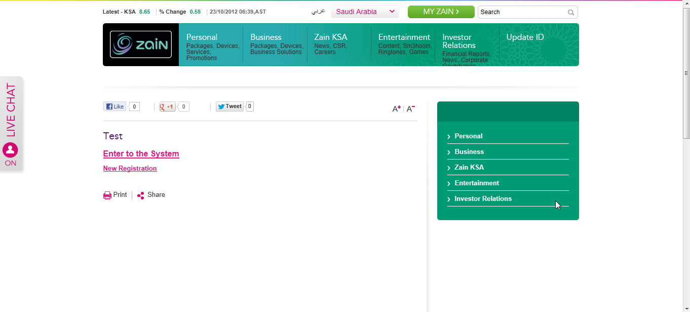

2- After clicking on previous Link you are kindly forwarded to registration page to enter the your main information for registration

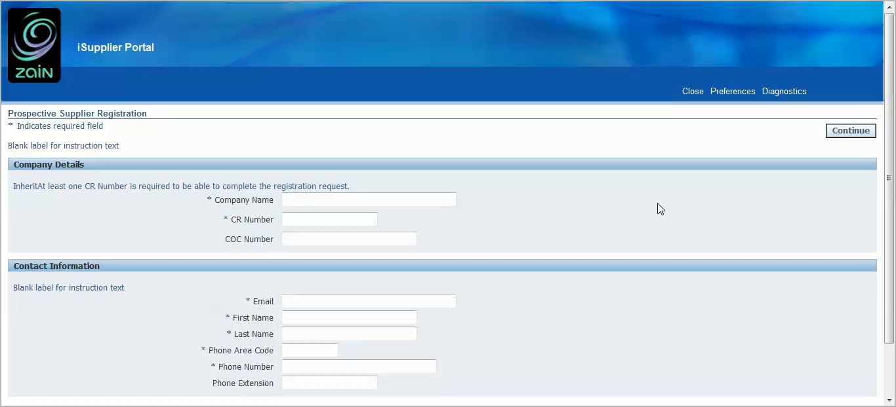

The first page of registration concerned with two main information:
- Supplier Identification Information
- Company Name: it is mandatory field where you are kindly requested to enter full company name as specified in the Commercial Registration Certificate (written in English). This name will be validation information for ZAIN in registration request approval process.
- CR Number: it is mandatory field where you are kindly requested to enter the Commercial registration Certificate Number which issued by Chamber of Commerce. This name will be validation information for ZAIN in registration request approval process.
- COC Number: it is optional field where you are requested to enter the Certificate Of Commerce number.
- Supplier Contact Identification Information
- Email: it is mandatory field where you are requested to enter the main contact person email account. This account will by the main communication path from and to ZAIN specially in the registration process. This name will be validation information for ZAIN in registration request approval process. (This will be your Account Name)
- First Name : it is mandatory field where you are kindly requested to enter main contact person first name.
- Last Name : it is mandatory field where you are kindly requested to enter main contact person last name.
- Phone Area Code : it is mandatory field where you are kindly requested to enter main contact person phone area code number. (like 009661)
- Phone Number : it is mandatory field where you are kindly requested to enter main contact person phone number. (like 59XXXXX)
- Phone Extension : it is optional field where you are kindly requested to enter main contact person extension number if the previous is company number. (like 12XXXXXX)

So you will have the information entered like below
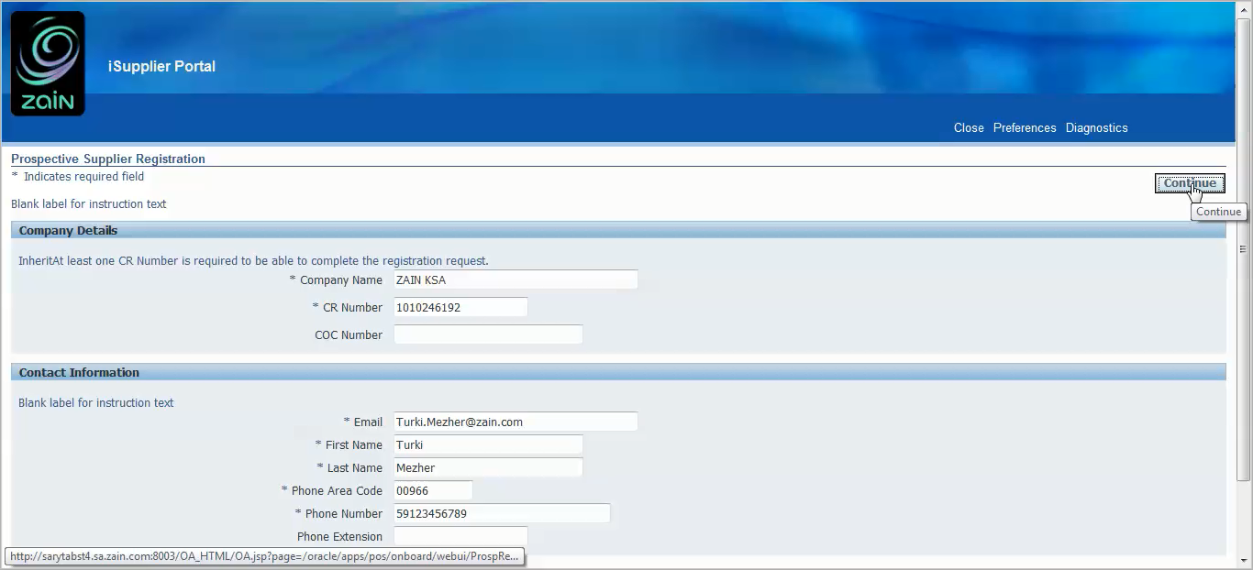

Then kindly press Continue button in order to be navigated to next page for registration request required information.

3- in the next page you will be kindly forwarded to the more professional details page where you are kindly requested to enter:
- Site Information
- Business Certificates Information
- Services and Products Information
- General Attachments
- General Information
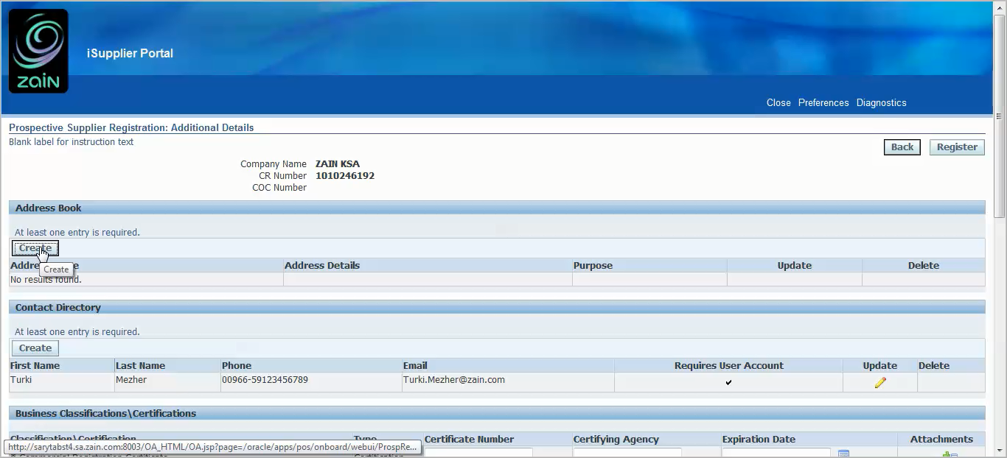

Site Region: once user click on Create Button enter the site details

4- Site Information
This form is specified with supplier site information which is mandatory for contractual purposes. The created purchase orders with ZAIN will be addressed to this site. The supplier user will map this address as the main billing address for all invoices created along with payments.
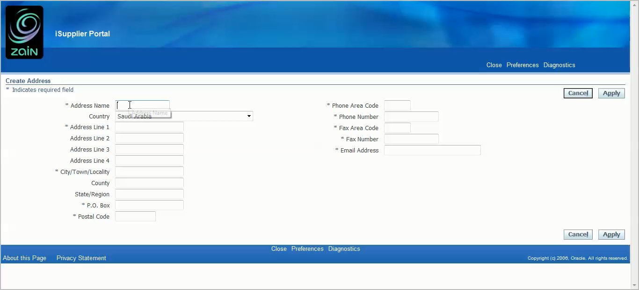
The main information in this form:
- Address Name : it is mandatory field where you are kindly requested to enter this is the branch name which will present supplier main branch name if the supplier has business oriented branches. Or can simply present the branch territory name if the supplier has different branches separated geographically in KSA or abroad.
- Country : it is mandatory field where you are kindly requested to enter the country where Branch specified
- Address Line 1: it is mandatory field where you are kindly requested to enter actual address details for branch which may be used for any further communication or mails.
- City: it is mandatory field where you are kindly requested to enter branch city name.
- P.O. Box : it is mandatory field where you are kindly requested to enter P.O. Box details
- Postal Code: it is mandatory field where you are kindly requested to enter Postal Code Details.
- Phone number: it is mandatory field where you are kindly requested to enter branch general number.
- Fax number: it is mandatory field where you are kindly requested to enter Branch fax number.
- Email: it is mandatory field where you are kindly requested to enter branch email account.

Once user is kindly fulfilled the required information in site form; you are kindly requested to Click on APPLY button in order to verify and save entered information and then navigate to next step which is the business certification information.

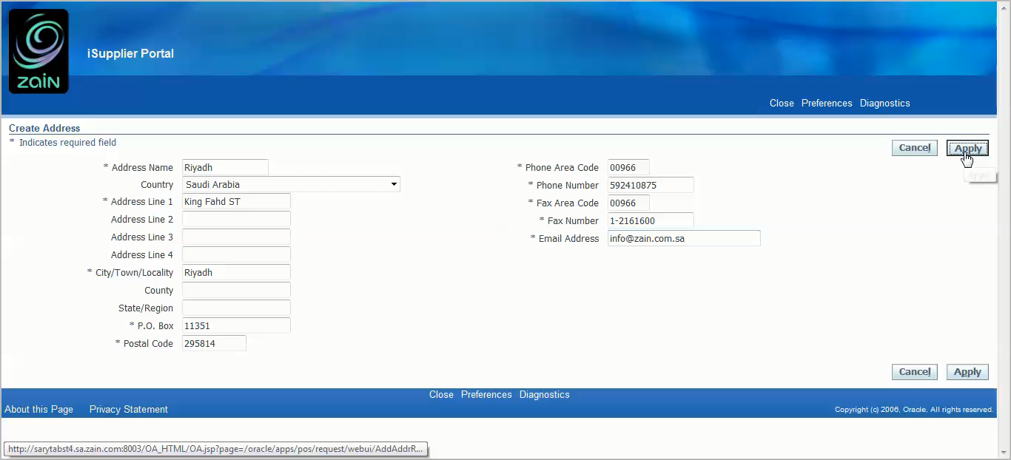

Now kindly notify the status of current request through entered information as follows:
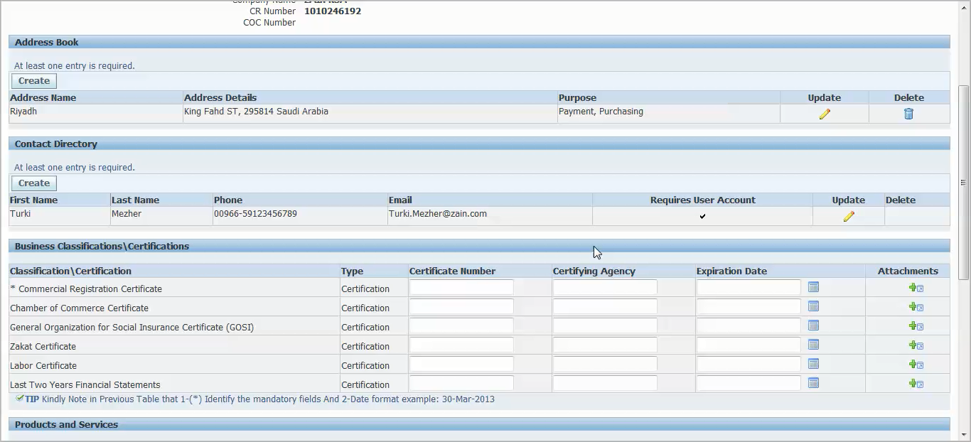

5- Business Certification
The supplier is kindly requested to enter Business Certifications information (mainly the governmental certifications as determined in the form) which are mandatory for any contractual or financial transactions with ZAIN. Kindly note that the information will be verified with ZAIN in order to maintain the accurate information or registration request will be rejected. Attaching soft copy of certificates is required for data verification and the request will not be submitted till it supported. The mandatory certifications are addressed with Start (*).
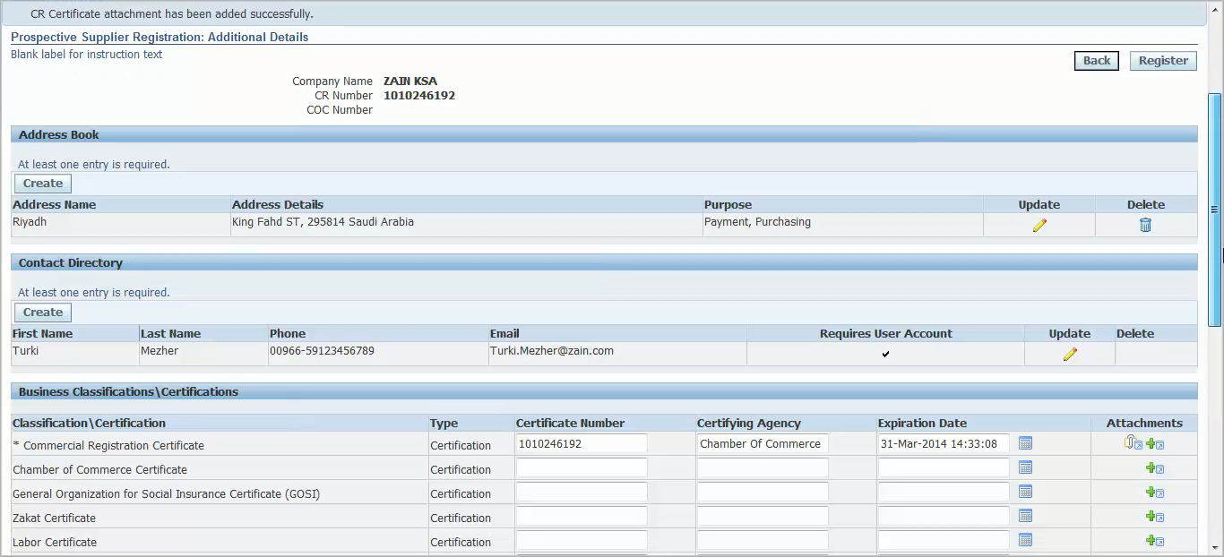

- Certification Number: it is mandatory field where you are kindly requested to enter the certification number.
- Certification Agency: it is mandatory field where you are kindly requested to enter the agency which issued certification.
- Expiration Date : it is mandatory field where you are kindly requested to enter certification expiration date; and kindly note that it is restricted to be future date.
- Attachments: it is mandatory field where you are kindly requested to attach soft copy of the certification.
- Cortication’s include: Commercial registration, Chamber of commerce, General Organization for Social Insurance (GOSI), Zakat Certificate (not required for new establishments), and Labor Certificate.

6- Products and Services
The supplier is kindly requested to enter the supported products and services which will provide to ZAIN; this information are mandatory for any contractual or financial transactions with ZAIN. Kindly note that the information will be verified with ZAIN in order to maintain the accurate information or registration request will be rejected.
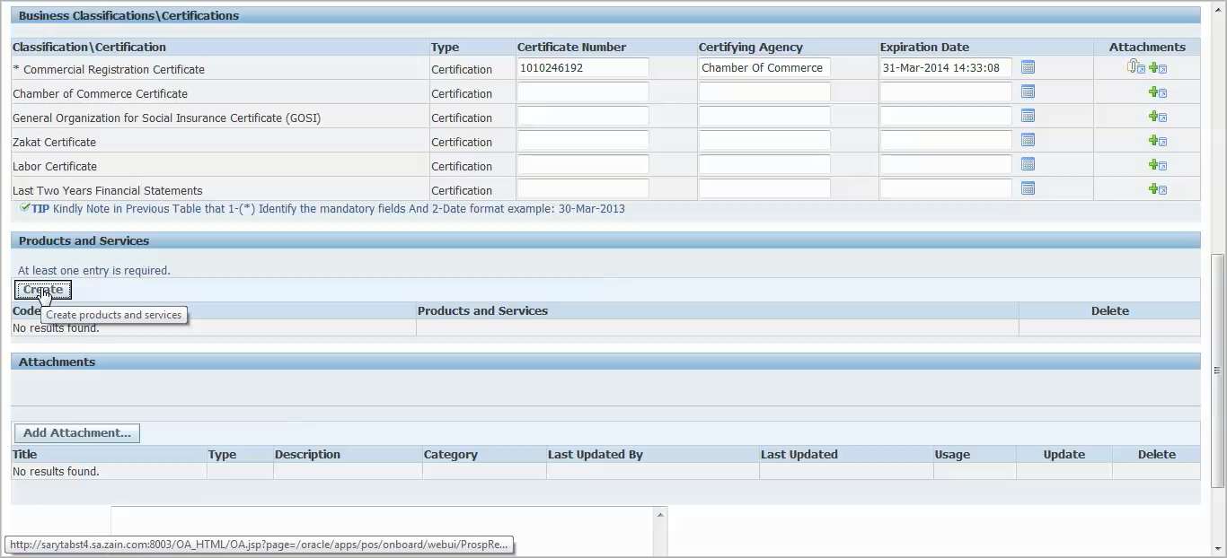
The supplier user is kindly requested in this stage to click on the CREATE button to create new records of supported products and services.
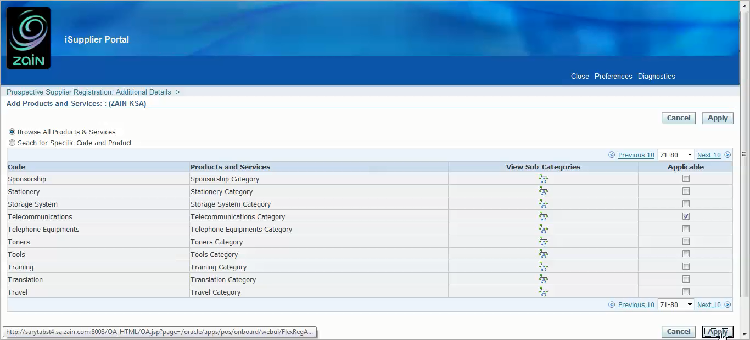
- Search for suitable products and services category and click on checkbox and then Apply.
7- General Information

In this section the supplier can whether support general information or attach general documents which considered needed for registration process

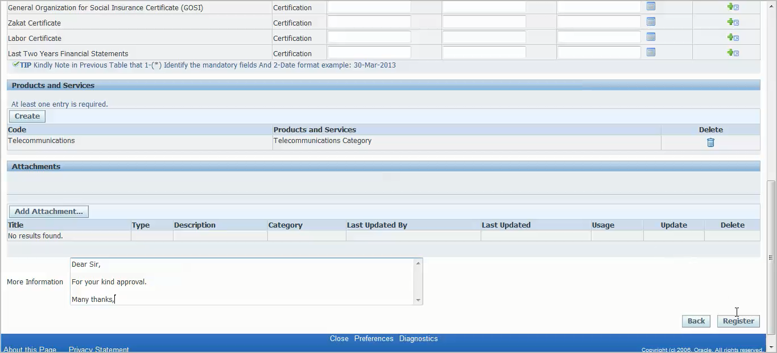
Finally the supplier user kindly requested to click on REGISTER button in order to submit the registration request for ZAIN concerned department for review and approval as bellow confirmation.
